Procedure Consent Form

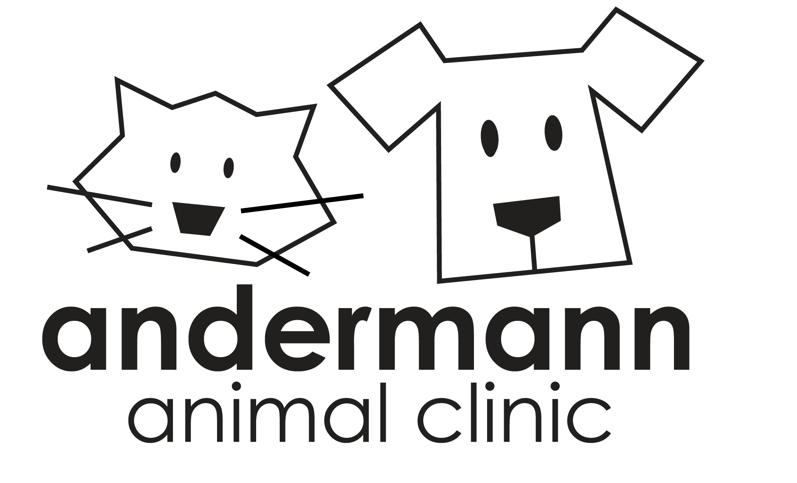
Leslie A. Andermann, DVM
3200 S. Burnside Ave. Gonzales, LA 70737 ● 225-647-7297

Pet Owner_______________________________________________________Date______________________

Address___________________________________________________________________________________

City, State___________________________________Phone__________________Cell____________________

Pet’s Name______________________________________________Breed______________________________

Pet’s Sex________________________Pet’s Color__________________________________________________

I____________________________________, am responsible for the above described animal and have the ability to give you my permission to receive, prescribe for, treat and /or operate upon my pet. I assume financial responsibility for all fees incurred while under the care of Andermann Animal Clinic. I hereby authorize the following procedure(s):

________________________________________________________________________________________

It is understood that all reasonable precautions against injury, escape or death of my pet will be used, but you will not be held liable or responsible in any manner in connection therewith as it is implicit that I assume all risks.

I acknowledge that there are certain risks to anesthesia that could involve serious bodily injury or death to my pet and that these risks are present in any procedures that require a general or intravenous anesthetic. I agree to the use of anesthesia as considered necessary and advisable by the veterinarian.

□ In the event that my animal requires emergency drugs and/or CPR – I want all measures taken to revive my pet and I understand that I am responsible for any additional fees associated with life-saving measures.
□ In the event of an emergency – do not resuscitate my pet.

After carefully reading the above, I have signed in agreement.

X__________________________________________
Legal Owner or Responsible Party

___________________________________________
Date

ADDITIONAL SERVICES – Please read carefully.
Our greatest concern is the well-being of your pet, especially during anesthesia. Prior to anesthesia, our staff will obtain a complete history of your pet, and the veterinarian will perform a complete physical examination. It is strongly recommended for your pet to have pre-anesthetic blood work. This bloodwork is a basic CBC and 6 panel blood chemistry. We can evaluate parameters such as liver and kidney function/health to make sure your pet is a good candidate for anesthesia. If all of the tests are normal, we can proceed with a greater degree of confidence and we will have established an excellent set of baseline values to use and compare against should your pet become ill in the future.
Additionally, there is also the option for IV catheter/IV fluid therapy during the procedure. IV fluids help to stabilize blood pressure and maintain adequate hydration while under anesthesia. Having an IV port in place also provides an easier route to administer IV drugs should an emergency arise under anesthesia.
*I understand that if I choose to add on the pre-anesthetic blood work and/or IV fluids, it in no way guarantees my pet from injury, death, or any other adverse event during the anesthetic procedure. I understand fully that there are inherent risks with any anesthetic procedure, regardless of tests.

□ Yes, I agree to the recommended pre-anesthetic bloodwork. This is an additional cost of $60.

□ Yes, I would like my pet to have an IV catheter and IV fluids during his/her procedure. This is an additional cost of $50

□ I decline the pre-anesthetic bloodwork.
□ I decline the IV catheter/IV fluids.

X__________________________________________
Legal Owner or Responsible Party

___________________________________________
Date

Other optional services that we can perform while your pet is under anesthesia are:

Nail Trim $10.00________ Basic Ear Cleaning $10.00____________Microchip service $45.00____________

ADDITIONAL REQUESTS AND/OR NOTES :
_____________________________________________________________________________________________________________________________________________________________________________________________________________________

